Table of Contents
News Guidelines 2
Why no PDFs of posters? 2
Formatting News Item’s 3
Title: 3
Summary: 3
Body Copy: 4
Sample – Basic Announcement 5
Sample - Link to news mention in external news websites 6
Sample - Event 7
The McMaster Style Guide 8
Abbreviations 8
Dates and Times 8
Italics 8
Numbers 8
Spelling 9
Usage 9

News Guidelines
Any news item posted on a Department site aggregates to the main news area of the Faculty of Social Sciences website. So, it’s important that Departments try to maintain consistent style and formatting in News items when possible to avoid the visual jumble that happens when we have different ways of writing headlines, dates, descriptions etc.

There are a number of different types of “news” a Department may wish to post on their site including:
- feature stories,
- announcements,
- events,
- and links to news mentions in local and national news websites.

Each type of post will have similar elements and should generally follow style guides. Please note, there are any number of types of announcements and news items will be generated. Our style guides are intended to remain flexible to accommodate individual needs.

There is one area where we cannot afford flexibility. We do not post links to PDF posters on the websites.

Why no PDFs of posters?
Everything that the posters say can be put into a news item. The advantage of using a news item three-fold…
- Almost 100% of the time a poster is not AODA compliant and causes major accessibility problems. A web page is accessible and compliant.
- When we put an article on the website and then upload a PDF of the poster we are actually creating two copies of the same information. This means that when someone does a Google search they may actually get two results for the same thing. That may not seem like a big deal until we scale it up over hundreds of documents and webpages… Things get pretty cluttered pretty fast.
- Another advantage in a web page – we can link! It is often convenient and desirable to have links in a story that point users to additional information.

Formatting News Item’s

Title:
Titles should be descriptive but brief. Titles should begin with a capital with the remaining sentence to be in a lower case unless the word is a proper noun. Avoid punctuation in a Title when possible.

Yes: New Social Sciences minors to debut in fall 2017
No: New! Social Sciences Minors to Debut in Fall 2017

Summary:
It is important to mention the Department the news or announcement originates from. Remember, this story will be aggregated with news items from 12 other sources on the Faculty page and may also be used in Social Media. The picture below shows a news item that is being linked to on a Facebook page.

The summary is an important way to draw people’s attention to your story. Short, descriptive, interesting are the attributes that are import in a summary.

Try to keep the summary under 40 words or 340 characters. As you can see in the image below summary is designed to show automatically display in Twitter and Facebook but there is a character limit. If your summary is too long it will be truncated.
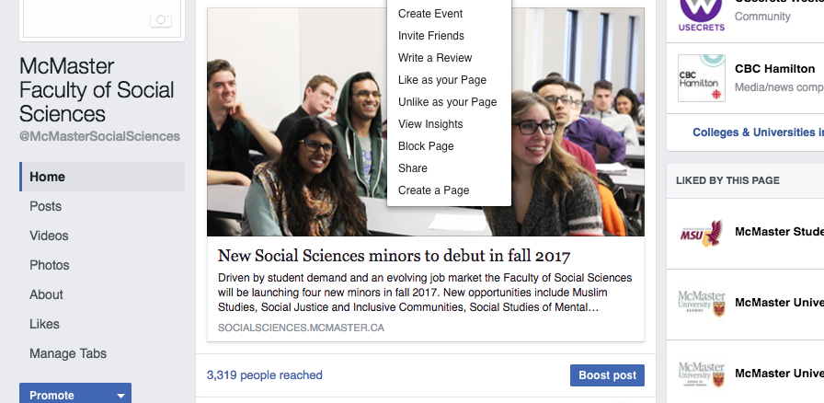

Body Copy:
An abbreviated version of the McMaster style guidelines can be found near the end of this document. Along with samples of the different types of posts you may come across.

One thing to note is hyperlinks (you may know the as links or weblinks). It is best practice to link on anchor text. Anchor text is the visible, clickable text in a hyperlink. In web browsers and word documents, it is often blue and underlined, on McMaster websites it is usually maroon.

When adding links to your stories try to add the hyperlink to words that describe where the link points to instead of just the big long link from the top of your web page.

No: http://www.cbc.ca/news/canada/newfoundland-labrador/beothuk-dna-ancestry-genetics-1.3953668

Yes: Read the full story on CBC News

Why link on words and not just leave the big long like we see it in the browser? A couple of reasons…

- The long link is not user friendly. It is super hard to read and becomes a visual jumble on the page.
- Accessibility. By putting the link on the words a screen reader will say out loud “Link. Full story on CBC News.”
If you leave just the long link the screen reader will say out loud
“Link. www.cbc.ca backslash news backslash Canada backlash Newfoundland dash Labrador backslash Beothuk dash dna dahs ancestry dash genetics dash 1 period 395368“.
Imagine how annoying that would be to listen to.

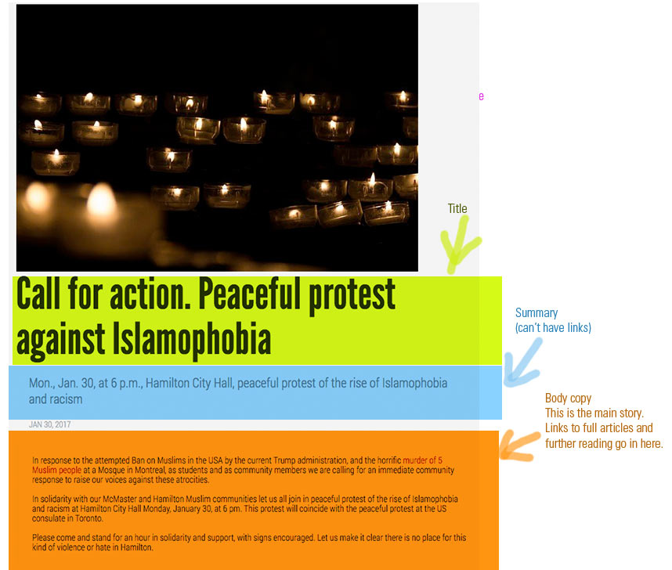
Sample – Basic Announcement
Notes:
- TITLE: The title starts with a capital but only nouns and acronyms are capitalized. No punctuation on the end.
- SUMMARY: Notice the abbreviated ‘Nov.’ and there are no ‘th’ on the end of the numerals.
- BODY: Short text broken into easy to read paragraphs.

Sample - Link to news mention in external news websites
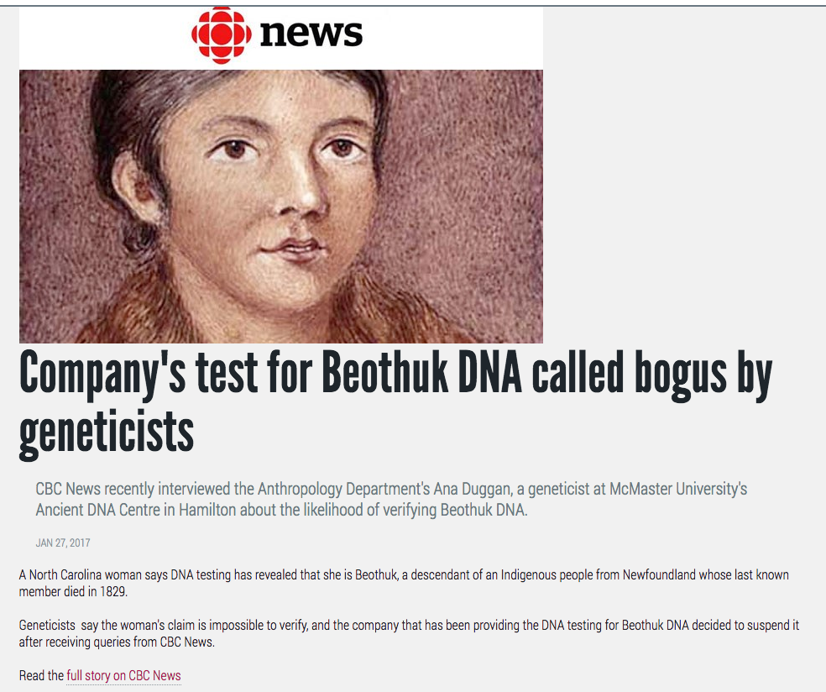

Notes:
- TITLE: The title starts with a capital but only nouns and acronyms are capitalized.
- SUMMARY: It is important to mention the Department the News originates from. remember this story will be aggregated with news from 12 other sources on the Faculty page. It is also important to note the news outlet the story originated from.
- BODY: Copy a short piece of text (one paragraph or a couple of sentences) to peak the readers interest in the story. At the end of the “lead sentence” add the link to the story.
Notice the link is on anchor text.

Sample - Event
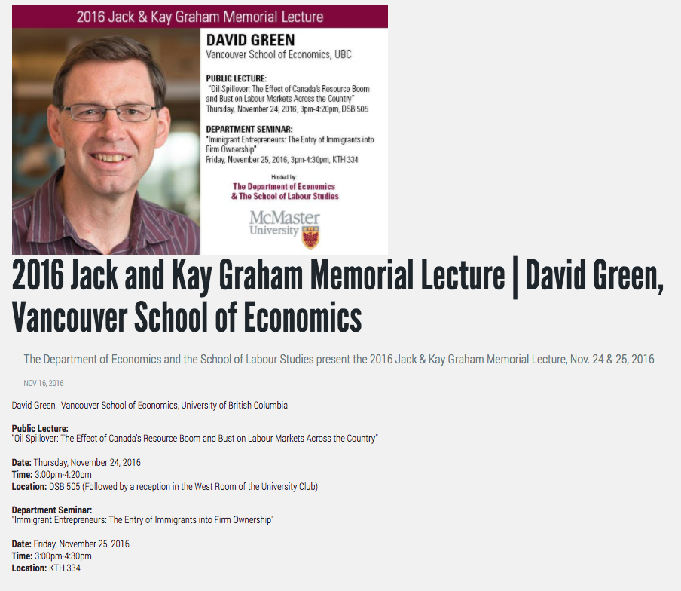
Notes:
- TITLE: Uses the ‘pipe’ | character to break up title
- SUMMARY: Notice the abbreviated ‘Nov.’ and there are no ‘th’ on the end of the numerals. The Departments are mentioned here.
- BODY: Date, time and location of the event are very clear and highlighted with bolding.

The McMaster Style Guide
Publications produced by the Office of Public Relations use Canadian Press Style (CP) for abbreviations, acronyms, capitalization, dates and times, spelling, type styles and usage, with the following house style guides. https://www.mcmaster.ca/opr/html/opr/mcmaster_brand/writing_guidelines/style%20guide.pdf

Abbreviations
Use periods in lower-case or mixed abbreviations, such as e.g., i.e., B. Comm., etc. Periods go at the end of abbreviations like B. Comm., B.Sc., Dr., Aug., Wed., but not abbreviations that begin and end with a cap, e.g., PhD, PoW, MiG, U of T, etc.

Some common academic degree abbreviations BA, MA, PhD

Dates and Times
Dates/days
No st, nd, rd, or th on numbers in dates: Jan. 1, not Jan. 1st. For months used with a specific date, abbreviate only Jan., Feb., Aug., Sept., Oct., Nov. and Dec. Spell out standing alone or with a year alone. Convocation was held Nov. 17, 2006. The Peace Camp lasted through January 1991. Days of the week are abbreviated only in tabular matter. (CP)

Date ranges
Use the word ‘to’ or ‘and’ to indicate a range of consecutive calendar dates or weekdays. You can use a hyphen if the dates appear in a table.

Monday to Friday
Monday-Friday
May 1 to 31, 2018
May 1-31, 2018

Hours
No :00 for exact hours The service will begin at 11 a.m. (not 11:00 a.m.) 12 noon and 12 midnight (rather than 12 a.m. or 12 p.m.) a.m. and p.m. Use periods after each letter, no space between. Use lower-case; never use caps.

Italics
Used for titles of books, long poems, plays, periodicals (including newspapers), pamphlets, published speeches, long musical works, movies, television and radio programs, works of visual art, names of ships, aircraft, space craft and trains, foreign words and phrases that are not part of the English language, (except alma mater—leave plain).

Numbers
Spell out numbers from one to nine; use figures for 10 and above. This includes ordinal numbers: first, not 1st; 20th, not twentieth, unless in an official title.

Spelling
advisor
(not –er) Note: this is a different spelling than CP’s

enroll
Spell enroll and its various forms with “commit” as the model, that is: enroll, enrolment, enrolled, enrolling. Note: this is not the same as CP spelling.

high school
Two words; therefore, hyphenate when the phrase is modifying: Student Liaison has a high-school liaison program.

master’s degree
Always has an apostrophe. He has a master’s degree in science. She’s graduating with her master’s in the fall.

post-doctoral (use the hyphen)

program (not programme) (CP)

Mosaic not MOSAIC

Usage
Telephone numbers
No parentheses around the area code: 416- 525-9140.

ext.
University extension numbers should always be preceded by ext. For more information, call James Street, ext. 4073. (not James Street, 4073)

Room numbers
When abbreviating, use the designated building abbreviation joined to the room number with a hyphen. CNH-321 TSH-505 HSC-1A1

Otherwise, use the building’s full name with followed by a comma, and the room number preceded by the word “Room” (cap R). Chester New Hall, Room 321*

In the profile pages of the Faculty of Social Sciences websites add the abbreviation in parenthesis after the building name Chester New Hall (CNH), Room 532

